**2048 Final Project User Guide**

**Installation Guide**

In order to run this program, the user must have NetBeans IDE installed on their computer. Follow these steps to get the 2048 game installed:

1. Use this link to go to the Oracle website where you can follow the steps to download NetBeans: <http://www.oracle.com/technetwork/developer-tools/netbeans/downloads/index.html>
2. After installing NetBeans, launch NetBeans.
3. Once in, click on File 🡪 Import Project 🡪 From zip..
4. Then click “Browse” and select the .zip file of the program.
5. Click “Import.”
6. The program should then load up. Click the green run arrow at the top to run the program.
7. The program is now installed and running!

**Purpose**

The purpose of this program is to create a fun and entertaining game. The game created is 2048 and it is customized so that the colour scheme and design is unique and not like most 2048 games found online. Therefore, the main purpose of this game is to create a unique version of the 2048 for the ICS4UE Final Project.

**How to Use**

This 2048 game program is not very difficult to use, and instructions are provided at each screen to guide users in playing the game. Here are the instructions:

1. At the start screen, click any key to launch the main game.
2. When the main game launches, click an arrow key to spawn the first tile and the game will start.
3. Use the arrow keys to move the tiles around. Tiles of the same value will combine to make tiles with double value. The goal is to make the largest tile; usually users should aim to make the 2048 tile, however there is no limit to how large the tile can be.
4. After one move while there are no empty squares, the main game screen will close and the game over screen will appear.
5. Type your name and click “Save” to add your name to the leaderboard.
6. Click “List” to display the leaderboard along with the usernames of the highest score holders.
7. You can now click “Restart Game” to launch the main game screen and close the game screen.
8. Refer to step 2.

**Special Features**

Game Over Screen – this is the screen you will see when the game board is full. It includes a leaderboard, score saver button, score lister button, and a button to reset the game.

Leaderboard – this is where the users with high scores and all user scores are outputted when the score lister button is pressed.

Main Game – this is the screen you will be taken to from the start screen. Click an arrow key to generate the first tile and the game will start. Click the arrow keys to move the tiles up, down, right, or left.

Reset Button – this button creates a new main game screen and closes the game over screen.

Score Lister Button – this button outputs the highest scorers and all the users’ scores to the leaderboard.

Score Saver Button – this button takes the user’s name and adds his/her name to the leaderboard which is output when the score lister button is pressed.

Start Screen - this is the screen that you will see once you run the game. Simply click any key and the game screen will show up and the start screen will close.

**Screen Captures**

Start Screen

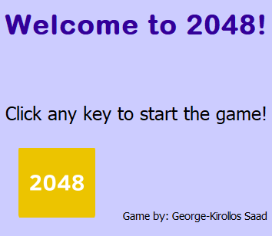

Main Game

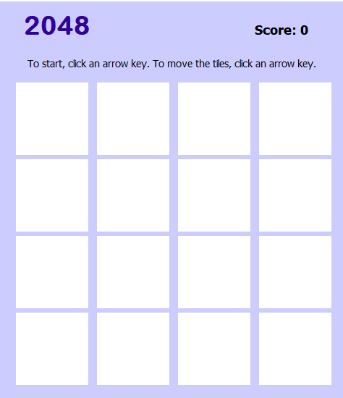

Game Over Screen

